**Google Sign In:** [**https://citria.org/sign-in**](https://citria.org/sign-in)

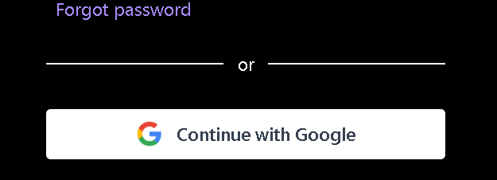

The provided code represents a React component named GoogleSignIn. This component facilitates the integration of Google Sign-In functionality into a React application. Here is a breakdown of its key features and functionalities:

Component Structure:

Import Statements:

The component imports necessary modules and components, including React hooks (useEffect, useState, useContext), external libraries (gapi-script for Google API integration, axios for HTTP requests), and a custom spinner component (SpinnerBtn).

State Initialization:

The component uses the useState hook to manage the state of loading, indicating whether the Google Sign-In process is in progress.

Context and Navigation:

The component utilizes the useContext hook to access the application context, allowing it to interact with shared state and functions.

The useNavigate hook is used for programmatic navigation within the application.

Effect Hook for Google Sign-In SDK:

The useEffect hook is employed to dynamically load the Google Sign-In SDK script (https://apis.google.com/js/platform.js) when the component mounts.

Google Sign-In Handling:

The handleLogin function is triggered when the user clicks the Google Sign-In button. It initializes the Google Sign-In API, performs user authentication, retrieves the user's Google profile information, and sends the id_token to the server for verification.

Server Communication:

The component uses Axios to make a POST request to the server endpoint (/user/google-sign-in) with the Google id_token.

Upon successful authentication, the server responds with an auth_token that is stored in local storage, indicating the user is logged in.

UI Rendering:

The component renders a Google Sign-In button with the Google logo.

During the Google Sign-In process, a loading spinner (SpinnerBtn) is displayed.

Conditional Styling:

The button's styling is adjusted based on the loading state to provide visual feedback to the user.

Conclusion:

The GoogleSignIn component encapsulates the logic required to implement Google Sign-In in a React application. It combines React hooks, the Google Sign-In SDK, and Axios for seamless authentication with Google.